Date: 17.09.2021

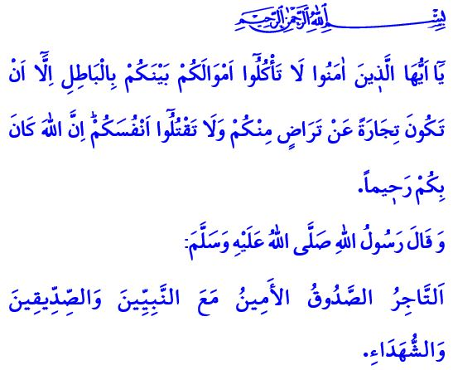
AWARENESS OF HALAL AND HARAM IN COMMERCIAL LIFE
Dear Muslims!
The Messenger of Allah (saw) had a habit. He (saw) would go to the Madinah market, exchange greetings with people there, and assess the market’s status. While wandering around the market one day, he (saw) came upon a wheat seller. He checked the heap of wheat with his hand. The top of the mound was dry while the bottom was moist. When asked why, the seller claimed it was because of the rain. Thereupon, our beloved Prophet (saw) warned the seller as follows, “Why did you not place this (the drenched part of the heap) over other eatables so that the people could see it? Whoever deceives us is not one of us.”
Dear Believers!
Our sublime religion Islam commands that we earn our income in halal and legitimate ways. It bans any transaction in which Allah’s (swt) pleasure, human rights, and halal-haram sensitivity are not observed. In this regard, Allah the Almighty (swt) states in the verse I have recited at the beginning of the khutbah as follows, “O you who have believed! Do not consume one another’s wealth unjustly but only [in lawful] business by mutual consent, and do not kill yourselves [or one another]. Indeed, Allah is to you ever Merciful.”
Dear Muslims!
The most important principles of business ethics, according to Islam, are integrity and honesty. A Muslim is someone from whose hands and tongue others are safe. A Muslim is someone who always instills trust in others about their affairs and business. They know that they will earn the pleasure of Allah (swt) to the extent that they are down-to-earth and honest, whether they are selling or buying something. They never resort to lies and deceptions. It is because the wealth obtained through dishonesty and deception brings no benefit.
Dear Believers!
A Muslim who believes in Allah (swt) and the Day of Judgment does not engage in haram and illegitimate means of making a living in their business. They do not participate in deceit or unfairness while measuring and weighing their items for sale. They do not swear an oath to sell their items for sale. They avoid black-marketing and do not act opportunistically. They do not victimize individuals by overcharging. They do not engage in unfair competition or intervene while a seller and buyer are in the middle of bargaining. In summary, they do not succumb to worldly desires and turn to haram.
Dear Muslims!
The Prophet Muhammad (saw) states in one hadith as follows, “An honest and trustworthy merchant will be with the prophets, the righteous, and the martyrs on the Day of Judgment.” So, let us not neglect our life in the Hereafter while earning our living in this temporary world. Let us be certain that not even a morsel-sized haram enters our mouths. May divine blessings abound in our homes and on our plates. May our ethics be founded on non-wastefulness, moderation, gratitude and contentedness.
I would like to conclude this Friday’s khutbah with the following advice from the Ahi Institution, the essence of which is rooted in Islam’s universal principles: “Control your hand, tongue, and what is under the belt! Keep your door and heart open, and stand in good conscience! Pay close attention to your spouse, job, and food! Do not look at haram, do not eat haram, and do not drink haram! Do not purposefully or unintentionally mismeasure anything! Do not fall prey to worldly possessions! Know to forgive when you are strong, and know to keep calm when you are angry!”

Muslim, Iman, 164.
Nisa, 4/29.
Tirmidhi, Buyu’, 4. General Directorate of Religious Services

